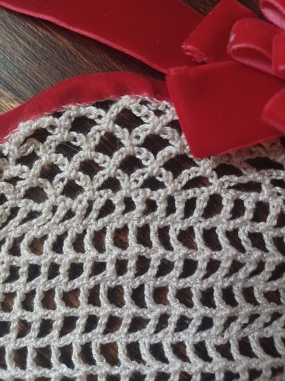
Hair Piece Pattern
Pattern by Ella Dieterlen, 2022-2023 Youth Leadership Team
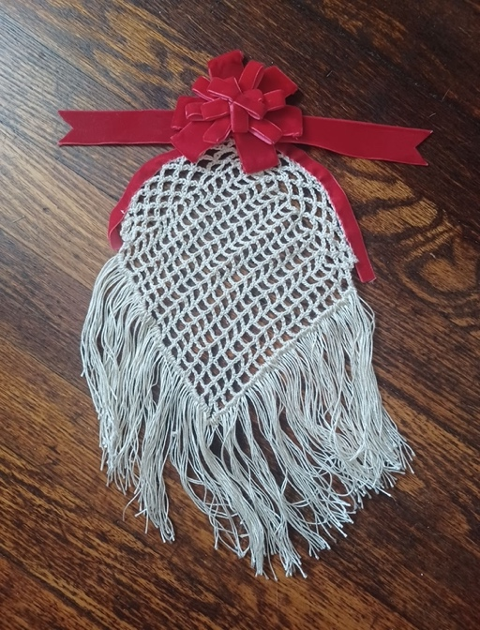
Abbreviations:
- Double crochet: dc
- Single crochet: sc
- Stitch: st
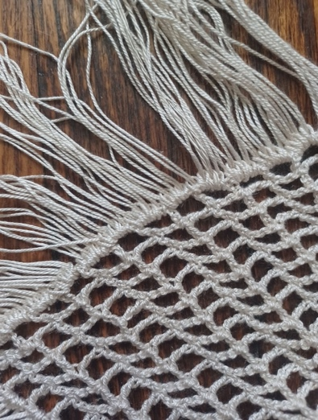
Supplies:
- 1 Fine Silk Yarn Ball
- 2.1 mm crochet hook
- Velvet decoration
- Thin floral wire
Pattern:
- Chain 67
- In the 8th chain from the hook dc. *Chain 2, skip 2 of the original chain then dc in the next stitch* repeat * around, join.
- Rounds 3-20 Chain 7, dc. *Chain 2, skip 2 of the original chain then dc in the next stitch* repeat * around, join.
- *Chain 7, slip stitch into the 2nd hole* repeat* around, join.
- *Chain 7, slip stitch into first chain 7* repeat* around, join.
- *Chain 7, slip stitch into first chain 7* repeat* around, join.
- *Chain 7, slip stitch into first chain 7* repeat* around, join.
- *Chain 7, slip stitch into first chain 7* repeat* around, join.
- Tie off, take the thin floral wire, then weave it into the last row of crochet. Take velvet ribbon and cover the wire. Decorate however you like with bows or flowers.
- After this cut 9 inch pieces of silk yarn and loop them into the bottom row. 4 should be in every loop.

