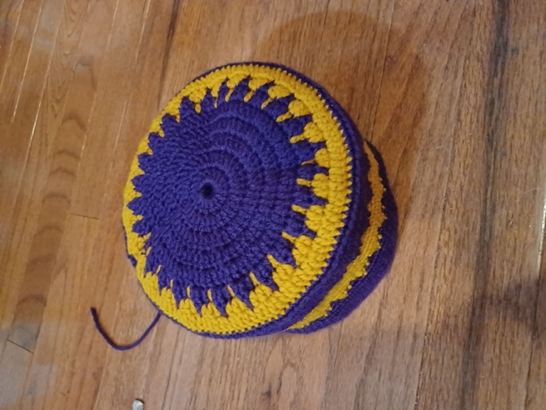
Smoking Hat Pattern
Pattern by Ella Dieterlen, 2022-2023 Youth Leadership Team

Abbreviations:
- Double crochet: dc
- Single crochet: sc
- Stitch: st
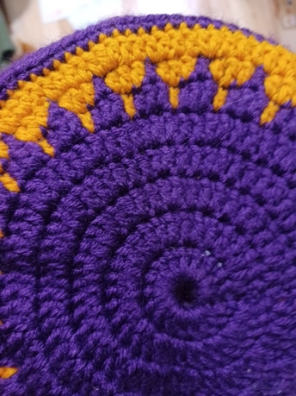
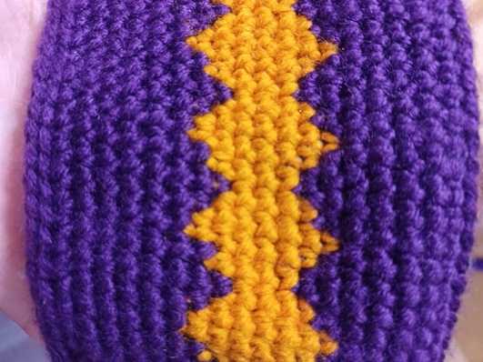
Supplies:
- 1 ball of navy blue wool yarn
- 1 ball of amber wool yarn
- Size E crochet hook
Pattern:
- Chain 7 and join in a ring.
- Chain 3, 16 dc in the ring, join.
- Chain 3, 2 dc in every st, join. 32 st in all
- Chain 3, *1 dc in the first st, 2 dc in the next stitch* repeat * around, join. 49 st in all
- Chain 3, *1 dc in the first 2 stitches, 2 dc in the next stitch* repeat* around, join. 66 st in all
- Chain 3, *1 dc in the first 3 stitches, 2 dc in the next stitch* repeat* around, join. 83 st in all
- Chain 3, work 1 dc on first 2 stitches. Stop before drawing the wool through the 2nd dc, then take the amber wool and finish the st with amber. Work the next st with amber but stop before pulling it through and finish the st with navy *2 navy dc in next st, 1 dc finished with amber. Work 1 dc starting with amber and finishing with navy* repeat* around, join.
- Chain 3, In the same switching fashion as step 7 work *1 navy dc, 3 amber dc* repeat* around, join.
- Chain 3, all amber *1 dc on first 6 st, 2 dc in the next st* repeat* around, join.
- Chain 2, all navy sc all the way around, join.
- Chain 2, all navy back loop only sc all the way around, join.
- Chain 2, all navy sc all the way around, join.
- Chain 2, all navy sc all the way around, join.
- Chain 2, all navy sc all the way around, join.
- Chain 2, all navy sc all the way around, join.
- Chain 2, change colors as described above *3 navy sc, 1 amber sc* repeat* around, join.
- Chain 2, *1 navy sc, 3 amber sc* repeat* around, join.
- Chain 2, all amber sc all the way around, join.
- Chain 2, all amber sc all the way around, join.
- Chain 2, all amber sc all the way around, join.
- Chain 2, all amber sc all the way around, join.
- Chain 2, all amber sc all the way around, join.
- Chain 2, *1 navy sc, 3 amber sc* repeat* around, join.
- Chain 2, *1 amber sc, 3 navy sc* repeat* around, join.
- Chain 2, all navy sc all the way around, join.
- Chain 2, all navy sc all the way around, join.
- Chain 2, all navy sc all the way around, join.
- Chain 2, all navy sc all the way around, join.
- Chain 2, all navy sc all the way around, join.
- Chain 2, all navy sc all the way around, join.
- Chain 2, strengthen the edge by working tight sc into the back loops of last round, join.
Often, smoking hats had tassels coming out of the top, so feel free to add a tassel.

