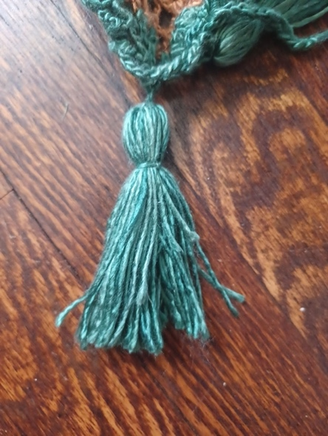
Snood Pattern
Pattern by Ella Dieterlen, 2022-2023 Youth Leadership Team

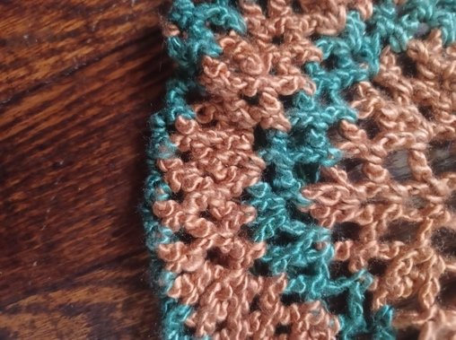
Abbreviations:
- Double crochet: dc
- Single crochet: sc
- Stitch: st
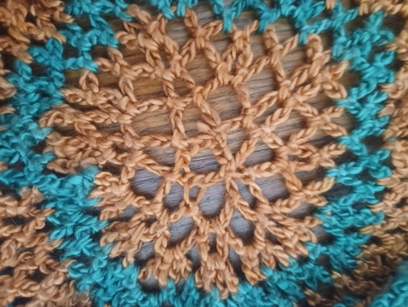
Supplies:
- 1 skein gold silk yarn
- 1 skein brown silk yarn
- 2 gold tassels
Pattern:
- With brown, Chain 12, join to form ring.
- Chain 5, join into second st from hook, *chain 5, join into every other stitch* repeat * around, join.
- *Chain 5, join into first chain loop from the hook. Chain 5, join to next chain loop, chain 5 join to the same chain loop* repeat* around.
- *Chain 5, join into first chain loop from the hook. Chain 5, join to next chain loop, chain 5 join to the same chain loop* repeat* around.
- Using gold, *Chain 5, join into first chain loop from the hook. Inc in the 4 chain loop.* Repeat* around.
- *Chain 5, join into first chain loop from the hook. Inc in the 4 chain loop.* Repeat* around.
- Using brown, *Chain 5, join into first chain loop from the hook. Inc in the 4 chain loop.* Repeat* around.
- *Chain 5, join into first chain loop from the hook. Inc in the 4 chain loop.* Repeat* around.
- *Chain 5, join into first chain loop from the hook. Inc in the 4 chain loop.* Repeat* around.
- Using gold, *Chain 5, join into first chain loop from the hook. Inc in the 4 chain loop.* Repeat* around.
- *Chain 5, join into first chain loop from the hook. Inc in the 4 chain loop.* Repeat* around.
- Using brown, *Chain 5, join into first chain loop from the hook. Inc in the 4 chain loop.* Repeat* around.
- *Chain 5, join into first chain loop from the hook. Inc in the 4 chain loop.* Repeat* around.
- *Chain 5, join into first chain loop from the hook. Inc in the 4 chain loop.* Repeat* around.
- 6 rounds using gold, *Chain 5, join into first chain loop from hook. Dec on the 4th chain loop* repeat around.
In order to finish the snood, a cord and tassel need to be acquired. This cord and tassel were gold in the original pattern and the cord was woven into the final round and drawn close to the head and the tassels were decoration. Also noted there were more rounds in the original pattern, but this amount fit the size of head I was making it for, so I stopped. If you need to make it bigger, do so before the final 6 rounds.

